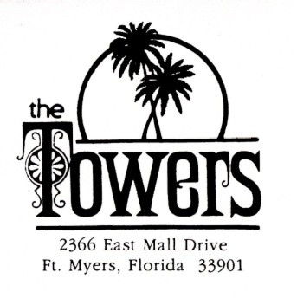

Hello to All Tower’s Residents:

It has been rumored that the Board of Directors have been hearing a few people would be interested in having an area for a book exchange.

WE will present to you the book exchange at the Towers Condominium. This is for any resident with a pool key to enter the common area following and abiding by the rules and regulations of accessing the pool area. There will be conditions with having this book exchange. If the conditions are met the book exchange will stay, if they are not met the book exchange will be gone. So, bring a book to the cabinet!

- No X-rated books.
- No books pertaining to sex in any way.
- If you have any books you no longer want it would be great to have you donate them to the book exchange.
- You can put hard copy or paperback books in cabinet.
- Books to put in cabinet are examples: western, comedy, science fiction, auto biography, nonfiction, fiction etc.

I will add to the list of conditions are they arise so please look at the notice that will be posted on the bulletin board next to the cabinet.

If you have any questions regarding the book exchange please call me.

Terry Maine
Member at Large
618-980-2365

Enjoy Reading!!

